Exercise 7 – Implementing the Observer Pattern

Scenario
Develop a stock market monitoring application where multiple clients receive updates whenever stock prices change.

Understanding the Observer Pattern
The Observer Pattern defines a one-to-many relationship between objects so that when the subject changes state, all registered observers are automatically notified.

Project Name
ObserverPatternExample

Implementation
import java.util.*;
interface Observer{
void update(double price);
}
interface Stock{
void registerObserver(Observer o);
void deregisterObserver(Observer o);
void notifyObservers();
}
class StockMarket implements Stock{
private List<Observer> observers=new ArrayList<>();
private double price;
public void registerObserver(Observer o){ observers.add(o); }
public void deregisterObserver(Observer o){ observers.remove(o); }
public void setPrice(double price){
this.price=price;
notifyObservers();
}
public void notifyObservers(){
for(Observer o:observers) o.update(price);
}
}
class MobileApp implements Observer{
public void update(double price){
System.out.println("Mobile App : Stock Price Updated to "+price);
}
}
class WebApp implements Observer{
public void update(double price){
System.out.println("Web App : Stock Price Updated to "+price);
}
}
public class ObserverTest{
public static void main(String[] args){
StockMarket market=new StockMarket();
market.registerObserver(new MobileApp());
market.registerObserver(new WebApp());
market.setPrice(250.50);
market.setPrice(255.75);
System.out.println("\nObserver Pattern executed successfully.");
}
}

Sample Output
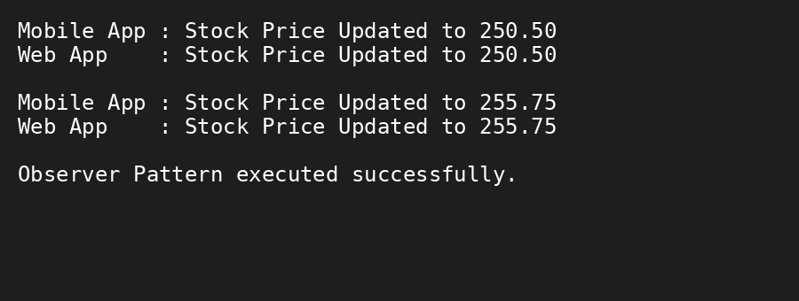

Conclusion
The Observer Pattern enables automatic notification of multiple observers whenever the stock market state changes.

